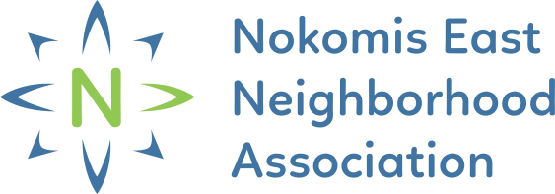
NENA HOME SECURITY REBATE
REQUEST FOR REIMBURSEMENT
Section 1 – Applicant Information
To be completed by applicant. Typed forms are preferred.
Form Submission Date
The applicant has 90 days from the application to complete the project and submit a Request for Reimbursement Form. If the applicant fails to do so, the funds will be reallocated to other applications and you will not receive a rebate.
Applicant Name
Applicant Address
Property Address
(If Different from Applicant Address)
Applicant Email Address & Phone | Email |  |  | Phone
Applicant Affiliation | Homeowner Tenant Property Owner
Homeowners / Property Owner Proceed to Section 2
Tenants must property owner review and approve the completion of the project  Written Approval Submitted |  | Property Owner Name:  Property Owner Phone Number:  Property Owner Email:
Part 2 – Project Expenses
To be completed by applicant. List the total estimated costs of the project, such as supplies, materials, work time (not including owner's work time).
Home Security Improvement Item(s) | Final Costs
Total Expense:
Total Rebate:
50% of total up to $500
* Final reimbursement will be based on actual expenses and will not exceed $500
Part 3 – Documents
I have included:
Completed Request for Reimbursement Form
Copies of receipts of items purchased and labor expenses
After Photos
Written Approval of Property Owner (if applicable)
Part 4 – Signature
I attest the information provided above is true and accurate and understand that any misrepresentation may result in the rejection of this application.

Applicant Signature Date

Submit completed Request for Reimbursement Form along with required documentation to the Nokomis East Neighborhood Association (NENA) at nena@nokomiseast.org or by mailing to 4313 E. 54th Street, Minneapolis, MN 55417.
Questions? Please email nena@nokomiseast.org or call (612) 724-5652

