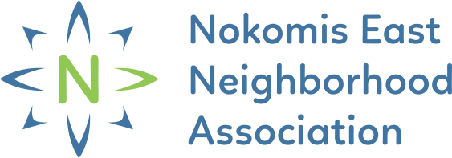
An online application is available at: https://forms.gle/Q3XA94tjegDEqcXy5
NENA HOME SECURITY REBATE APPLICATION
Section 1 – Applicant Information
To be completed by applicant. Typed applications are preferred.
Applicant Name
Applicant Address
Property Address
(If Different from Applicant Address)
Applicant Email Address & Phone | Email |  | Phone
Applicant Affiliation | Homeowner Tenant Property Owner
Homeowners / Property Owner Proceed to Section 2
Tenants must have permission from the property owner to make improvements listed below. Please submit written permission from the property owner with this application.  Written Permission Submitted |  | Property Owner Name:  Property Owner Phone Number:  Property Owner Email:

Part 2 – Project Budget
To be completed by applicant. List the total estimated costs of the project, such as supplies, materials, work time (not including owner's work time).
Home Security Improvement Item(s) | Estimated Costs
Total Expense:
Total Rebate:
50% of total up to $500
* Final reimbursement will be based on actual expenses and will not exceed $500

Part 3 – Documents
To be completed by applicant.
I have included:
Completed Application
Before Photos
Written Permission of Property Owner (if applicable)
Part 4 – Project Completion Deadline
The applicant has six (6) months from the signing of this application (See Section 6), to complete the project and submit a Request for Reimbursement Form. If the applicant fails to do so, the funds will be reallocated to other applications and you will not receive a rebate.

Part 5 – Signature
To be completed by applicant.
I attest the information provided above is true and accurate and understand that any misrepresentation may result in the rejection of this application.

Applicant Signature Date

Submit completed application along with required documentation to the Nokomis East Neighborhood Association (NENA) at nena@nokomiseast.org or by mailing to 4313 E. 54th Street, Minneapolis, MN 55417. Scanning is preferred to mailing.

Questions? Please email nena@nokomiseast.org or call (612) 724-5652

